**ELEMENTS OF POWER SYSTEMS**

**EXPERIMENT 5**

**Codes:**

clc

clear all

r=input("enter the ratio X/R: ");

Pr=input("enter the reactive power: ");

Pm=input("enter the meanb power: ");

Pa = input("enter the apparent power: ");

E= input("enter voltage: ");

V= input("enter voltage: ");

Z= V^2/Pa

R=Z/sqrt(r^2+1)

X=r*R

a=(2*R*Pm-E^2+V^2)*V^2 +R^2*Pm^2+X^2*Pm^2;

b=2*V^2*X;

c=(X^2 + R^2);

p=[c b a];

Q=max(roots(p))

Qadd=Q-Pr

**Output:**

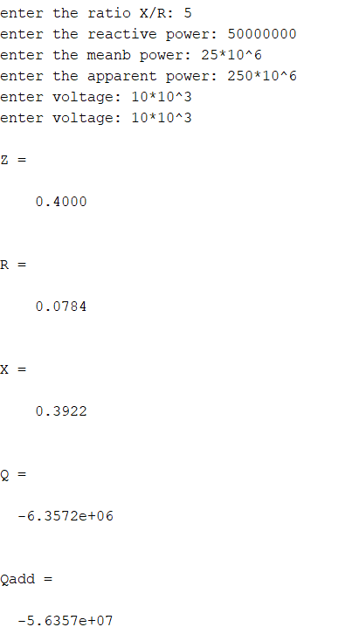

**MATLAB Circuit Diagram:**

**Without compensator:**

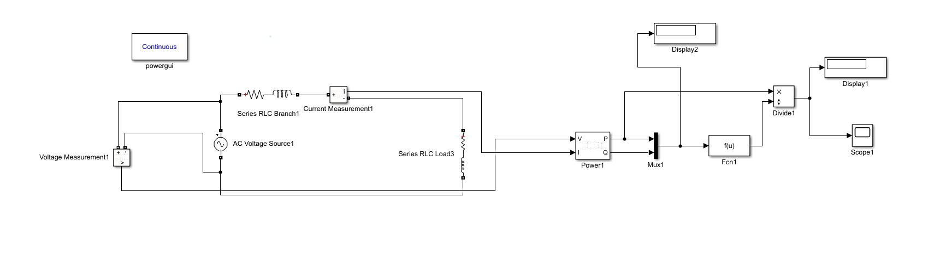

**With compensator:**

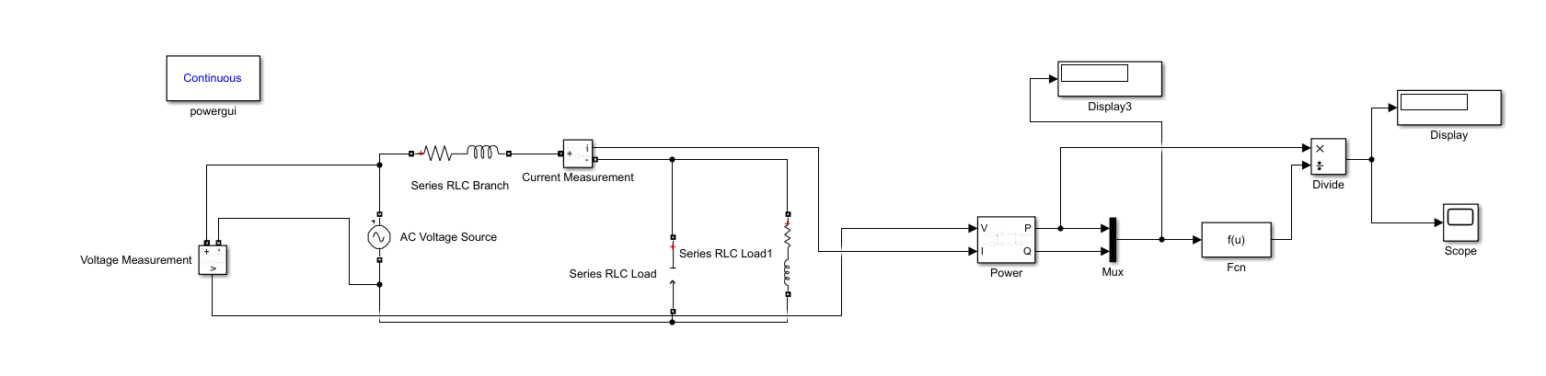

**Without compensator (Voltage and current graphs):**

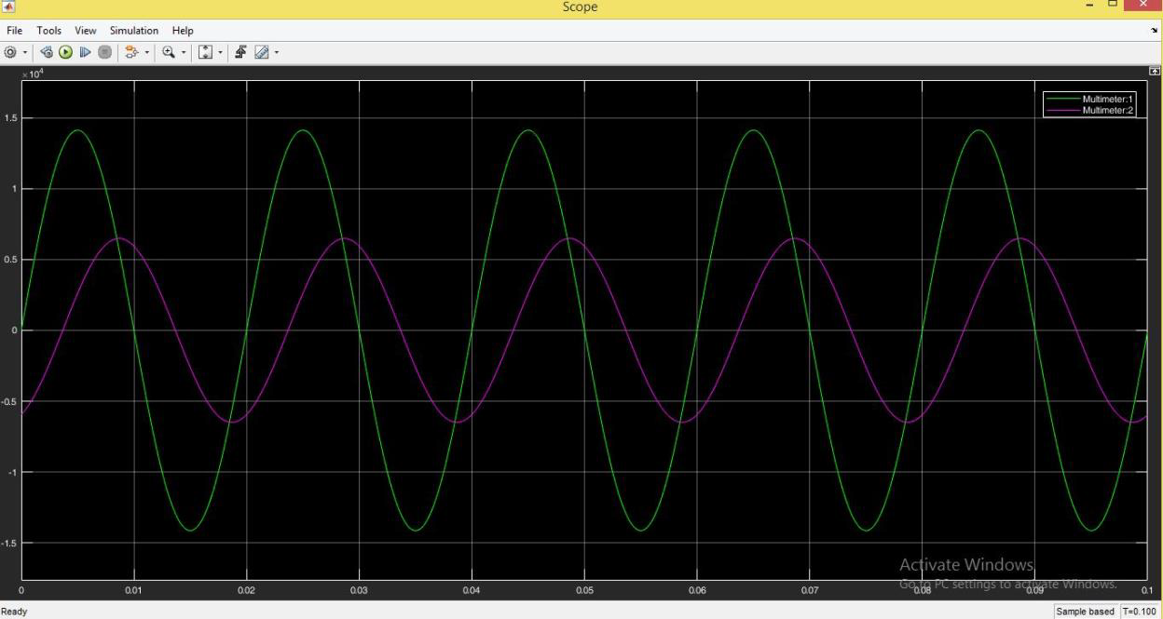

**With compensator (voltage and current graphs):**

